ConTest (version 3.2) Manual

Version: August 2021
This manual is developed for TU Delft instructors who want to use ConTest.

Contents:

What is ConTest? 3
Overview of the steps in the ConTest process: 3
Step 1: Create a new test in ConTest 4
Step 2: Print the answer sheets 8
Step 3: Having students take the test 9
Step 4: Bring your answer sheets to the ESA-desk 10
Step 5: The answer sheets are scanned and checked by ESA 10
Step 6: Receive raw data & test result report 10
Step 7: Analyse the results in ConTest OR in another application 11
Scoring: indicate the correct answers 12
Grading: how is the grade made up? 16
Data: reviewing students’ results 17
Reports: generating and exporting reports 18
Extra: Three anti-cheating options (versioning) 20
Questions and Contact 27

What is ConTest?
ConTest is a software based solution to facilitate the processing of paper-based exams using specific multiple choice answer sheets.

Overview of the steps in the ConTest process:

Figure 1. Overview of the process. Underlined parts are only applicable for ConTest account holders.

Do you need a ConTest account?
YES: If you want to use ConTest as a tool to grade and analyse your test results.
Mail to fab-contest@tudelft.nl to receive a ConTest account and add the following information:
  - Programme / Opleiding
  - Course code / Vakcode
  - Title course / Titel vak
  - Name instructor / Naam docent
- You will have to create your new tests in ConTest yourself.
- You will have to use a keyform (an answer sheet that has all the correct answers)
OR insert the correct answers in the new test
NO: If you only want to use the ConTest outcome (data file) of your test and analyse it in a different application than ConTest, you will not need a ConTest account.
- DigitalExams will create your new tests.
- You must use a keyform for your tests.

Step 1: Create a new test in ConTest

- This step is only for teachers with a ConTest account.
- If you don’t have (or want) a ConTest account you need to use a keyform (sheet with correct answers). You can skip step 1 and go to step 2.

How to create a new test
- Log in to ConTest: https://contest-os.tudelft.nl with your Net ID and password.
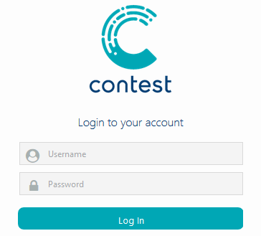
If you are working off Campus please use weblogin to navigate to ConTest: https://weblogin.tudelft.nl/vpn/index.html
- Select your programme and course in the organization tree (under “My Organization”)
- Click on New (right side) or New Test (left side)
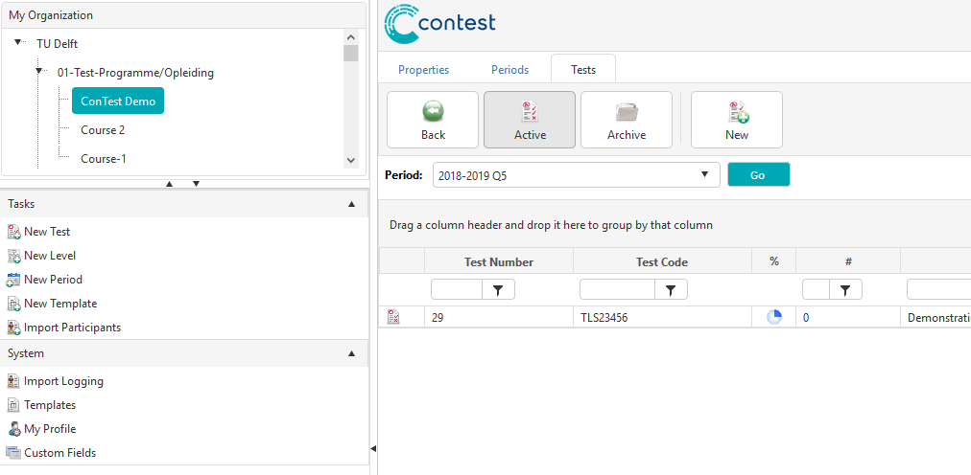

When you click on New or New Test you will have to fill out 5 steps:

Step 1: Enter a Test code, description and date for the test
- Your Test code is your Course Code!!
- Description: fill in what you like
- Click on Next.
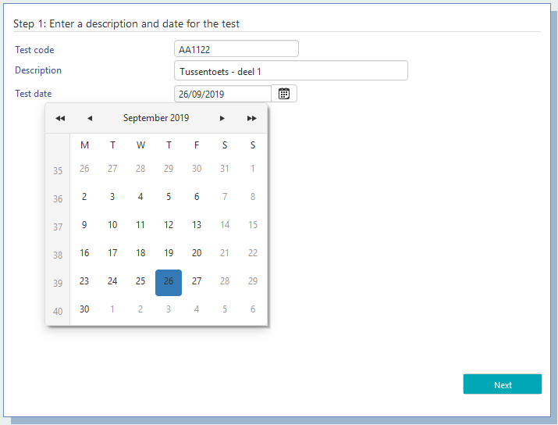

Step 2: Select a level
- Check whether your test is indeed in the correct programme and course.
- Click on Next
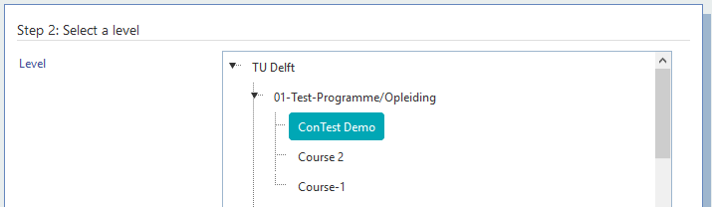

Step 3: Select a period
- Select the period in which your test takes place
(Q5 is the period in the summer break, with the re-sits).
- Click on Next
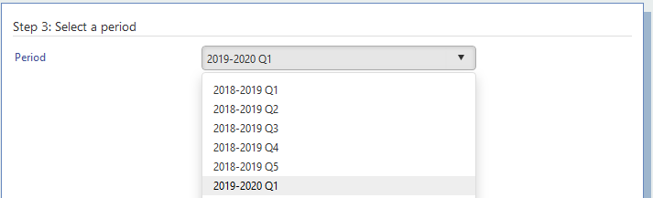

Step 4: Select a template
Select the ‘template’ (answer sheet) that you need:
- An answer sheet with 2 choices (True-False) with a maximum of 100 questions
- An answer sheet with 4 choices (A,B,C,D) with a maximum of 90 questions
- An answer sheet with 8 choices (A,B,C,D,E,F,G,H) with a maximum of 60 questions
- An answer sheet with 4 shuffled choices (C,B,D,A) with a maximum of 90 questions
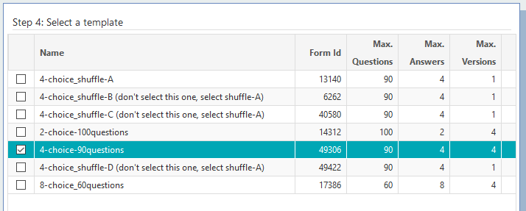
- Click on Next

Step 5: Questions and answers
- Number of questions: how many questions do you use in your exam? In this case: 40
- Maximum answers: this number corresponds with your answer sheet. In this case 4
- Question type: always 1
- Versions: 1 (see for more info on Versions, p. 20)
- Click on Finish
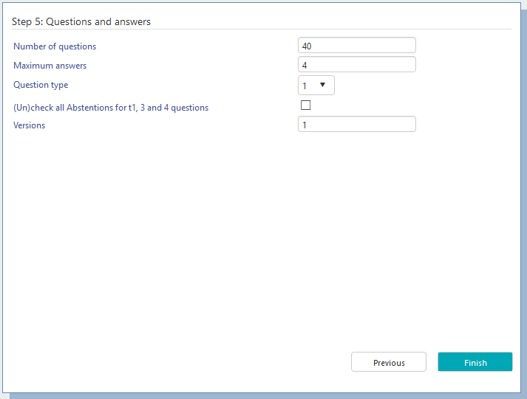

After completing the 5 steps, the Properties TAB of this new test will look like this:
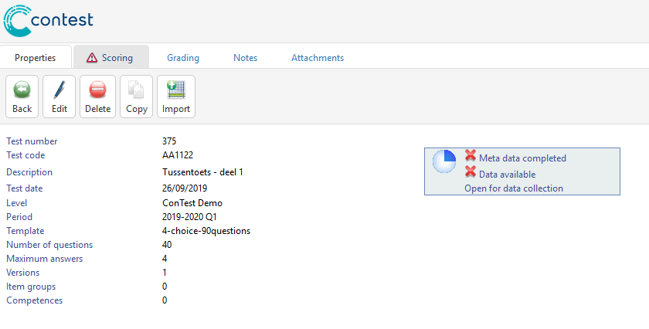
For each test, ConTest informs you about the stage and status the test is in. This is done by using both an icon and a description text.

Step 2: Print the answer sheets

Important
- It is NOT possible to use multiple answers on the answer sheets;
only ONE answer per question is possible to scan
- Answer sheets must be printed, not copied.
- Do not scale the print, keep it 100%
- Do not modify the answer sheet, if you do we cannot guarantee the forms will scan properly.
- Always use the latest version of the answer sheets here:
https://brightspace-support.tudelft.nl/contest/
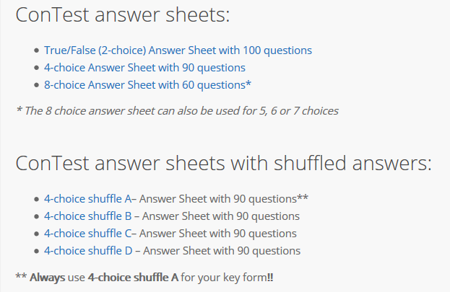

Step 3: Having students take the test

Please instruct your students to – besides filling in in the answers – also to fill out all red sections on the answer sheet in a clear and proper way. This way is it easier for DigitalExams to check, see Step 5.

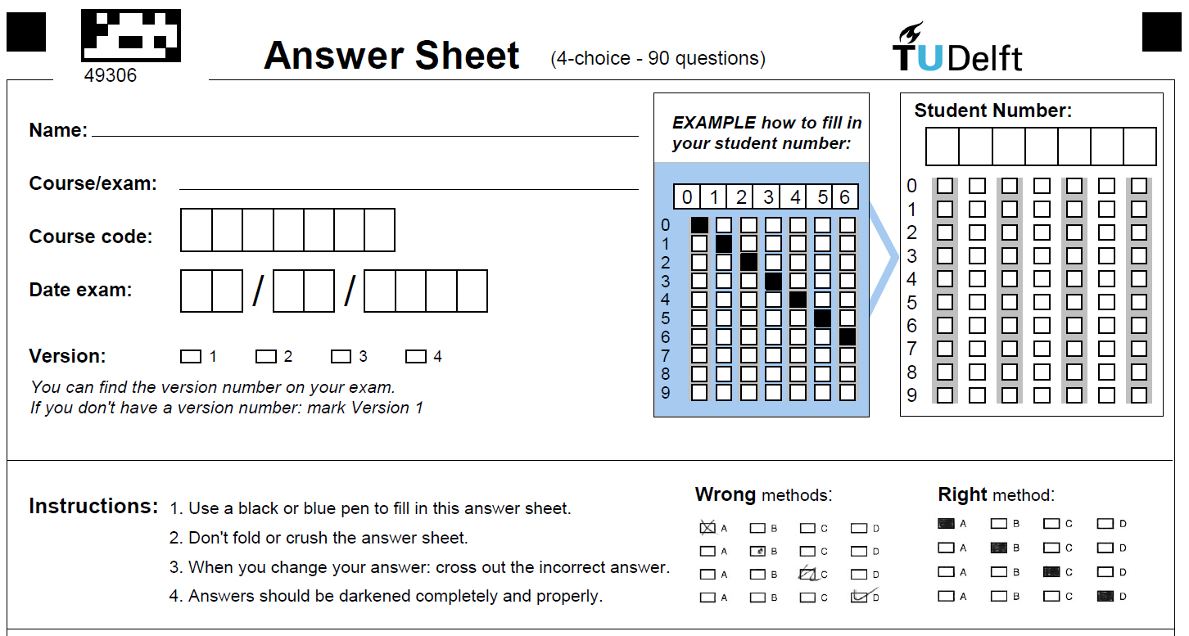

Step 4: Bring your answer sheets to the ESA-desk
Once you have collected the completed tests you can bring them to the ESA-desk.
- When handing them in, be sure to include your keyform, if using one. A keyform is an answer sheet that has all the correct answers prefilled.
- Furthermore, please fill out the intake form you will receive from the colleagues at the ESA-desk so they know what to do for your test.

Step 5: The answer sheets are scanned and checked by DigitalExams
After receiving your batch, our colleagues from DigitalExams will scan your forms as soon as possible.
The scanning software is triggered when:
- The student number is incorrect or not filled in
- The version number is incorrect or not filled in
- Two answers are given for one question
When this happens the corrector has to manually correct the student number or version number.
In case of two answers the corrector chooses the most filled in answer. If this is not clear the corrector selects NO answer which leaves the question “open”.

Step 6: Receive raw data & test result report
Within 3 working days you will receive a mail from the ConTest email address that will include:
- 1 standard report (in Excel)
- 1 standard data file (in CSV)
- Explanatory notes for the test result analysis (PDF)
If you have a ConTest Account you will be notified per email that the data is accessible.

Check your student’s results for open answers
This step needs to be done by the teacher as “open” answers can be the result of Step 5.
The easiest way to check if there are open questions is in the Report file > tab: Grading Report
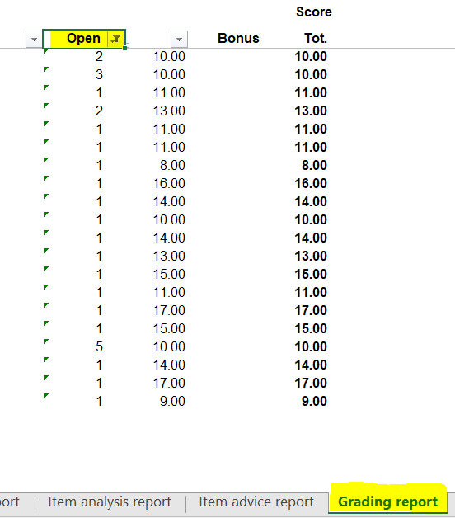

If you have a ConTest account you can check the student answer sheet in the Data tab:
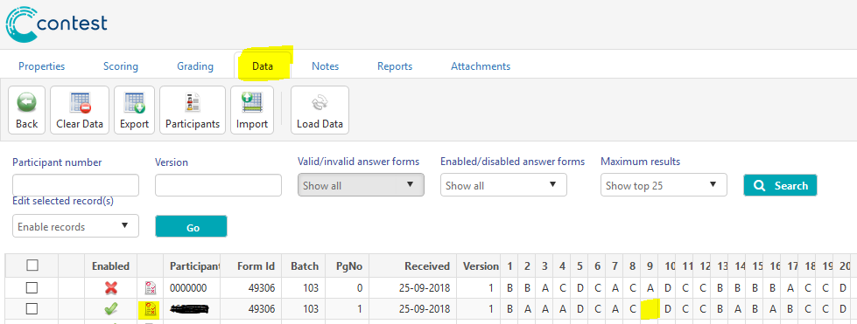
Click on the icon to see the scan and there you can verify the answer.
If you don’t have a ConTest account you will have to manually go through your batch of forms to verify the answer.

Step 7: Analyse the results in ConTest OR in another application
- In case you have an account in ConTest, you can analyse the results in ConTest
In other cases,
- You can analyse the test result analysis in the file that DigitalExams sent to you, or in another application(s).

Scoring: indicate the correct answers

‘Scoring’ is the step in which you assign points to all possible answers for every question in the test.
Under the ‘scoring’ tab, you indicate the correct answer per question.
When using a keyform, the scoring will be done automatically in the scanning process.

Scoring Tab:
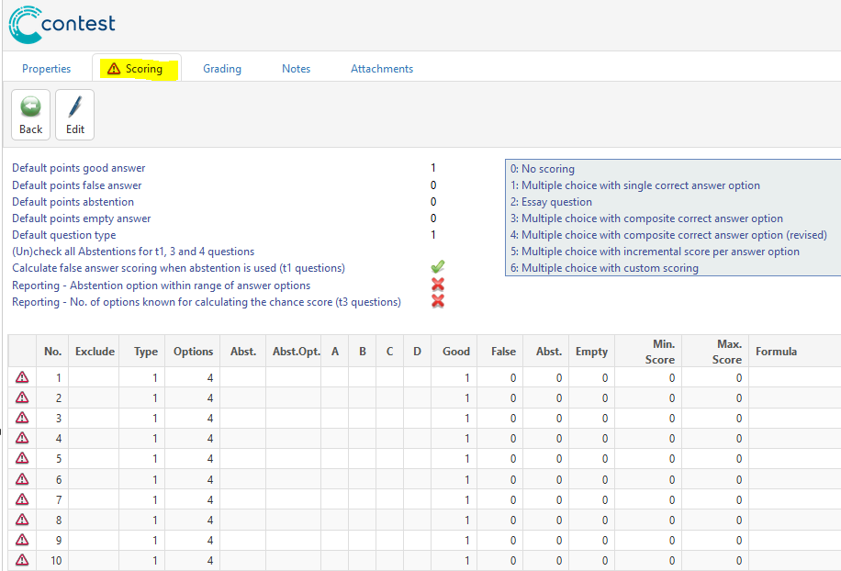

Scoring Tab after clicking on Edit button:

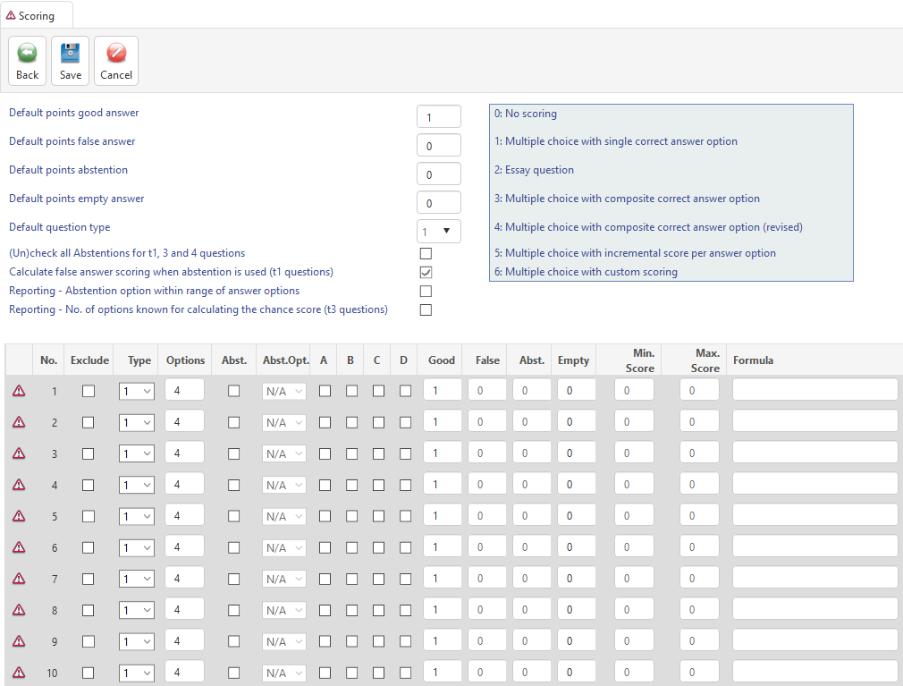
Overview of the question types

- Now you can edit the type of question and select the right answer(s).
Only change the type of question from 1 to 6 after the test result analysis (questions of type 6 will not be analysed, otherwise)!

Be aware that as long as a Tab still shows the exclamation mark you have not completed the required steps yet. Every time you complete a Tab, the exclamation mark will disappear.
Meaning exclamation mark:

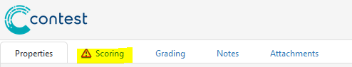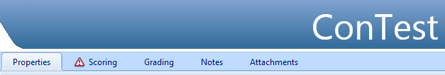

Question Types and scoring

ConTest supports 6 types of questions.
However, only the single selection options are supported at TU Delft.

Type 0: No scoring
You could use this type to ask for feedback from your students. Example:
How hard did you find the questions on topic X?
- much more difficult than I expected
- more difficult than I expected
- easier than I expected;
- much easier than I expected;

Type 1: Multiple choice with single correct answer option
The single option question type is the most frequently used question.

What is the largest province of the Netherlands?
- Drenthe
- Gelderland
- Friesland
- Zwolle
For the question that is displayed here, students get 1 point if they answer ‘B’. In any other cases, they get 0 points.
Type 2, 3, 4, and 5
These types are not available for the following reasons:
- Type 2: Essay question (open questions): It is not yet user friendly enough to enter data in Contest (chance of data loss), or to import data (data format for exporting is very different from that for importing). If you have an exam with a combination of open questions and closed questions, you are advised to calculate two grades (one for each question types) and take a weighted average of the two.
- Type 3, 4, and 5: Multiple choices with multiple answers possible per question: This is not possible with the current answer sheets.
Type 6: Multiple choice with custom scoring
Question type 6 will not be used for the test result analysis. Therefore, always start with question type 1, run the test result analysis (tab ‘reports’) and only then change the question types to type 6.
In case students can only tick one box, you might consider giving a partial grade for a partially correct answer. In this case, answer C is correct, but answer B is not so far off, so you give them ½ point.
You might also use start using this option for corrections after the test, for example, after discussion with students, or if triggered by the test result analysis.

Grading: how is the grade made up?

This is a screen of the standard Grade Settings:
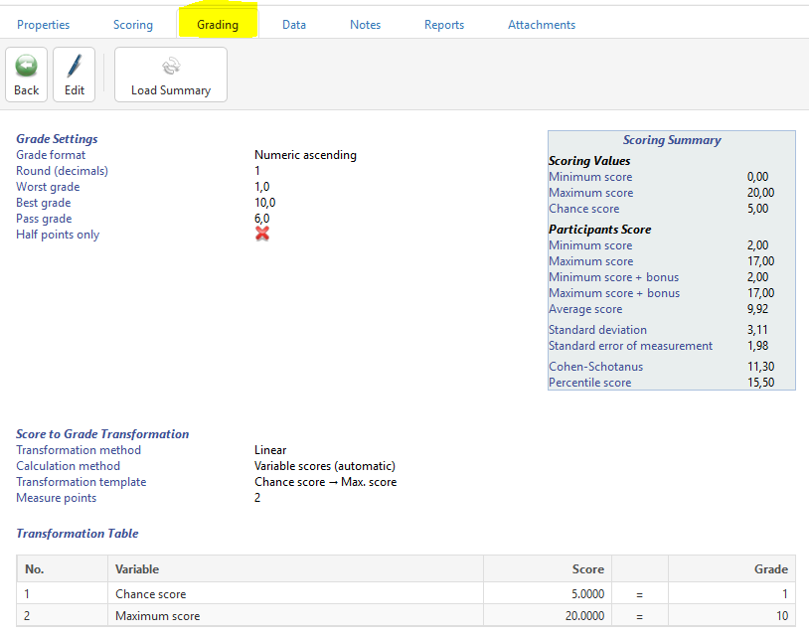

- If you want to change these settings you can use the Edit button.

Data: reviewing students’ results
Here you can see the answers of all students, and open the scans of the answer sheets of individual students.
- Go to the Data tab

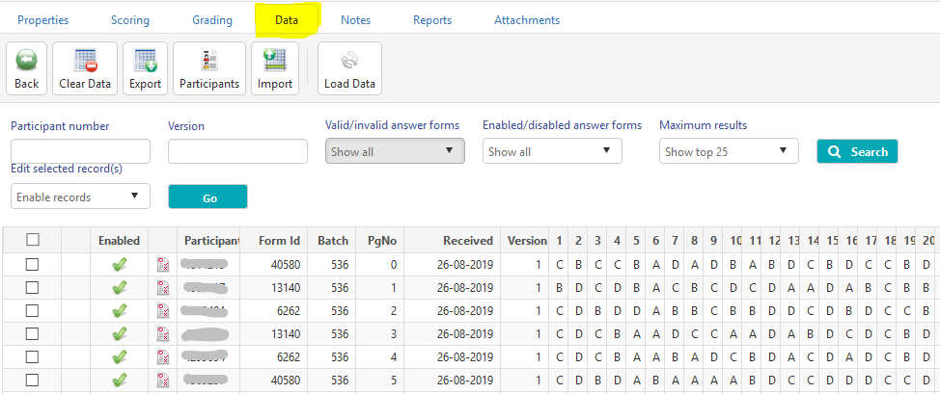
If you don’t see any results, click on the load data button

This will Export the answers of the students to a .csv-file

Click on the PDF icon to see the student answer sheet.
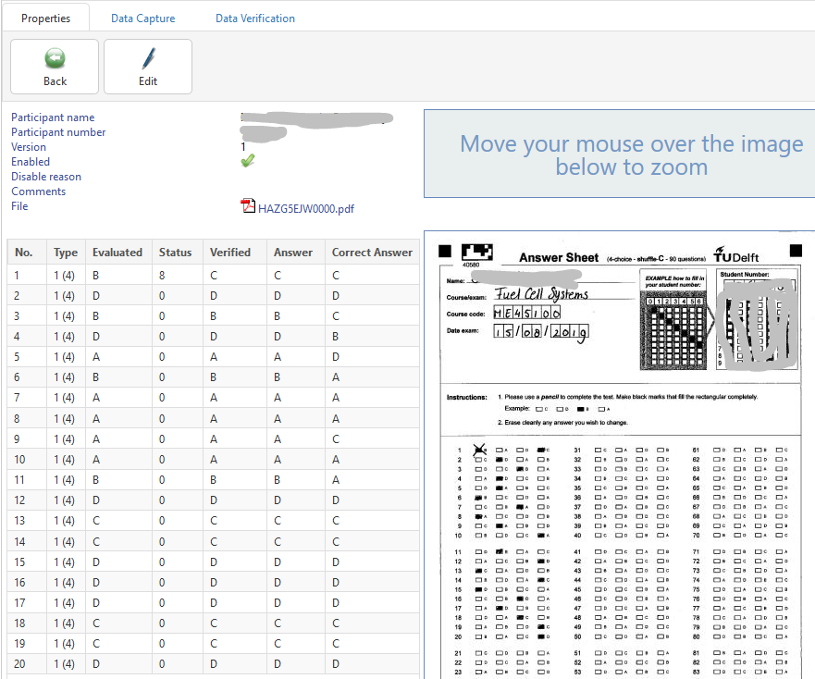

Reports: generating and exporting reports
Here you can generate the report of the test (test result analysis) and use this report to export the scores and grades of your students.
- Go to the Reports tab
- Click on Generate
- It takes a few moments to generate the report
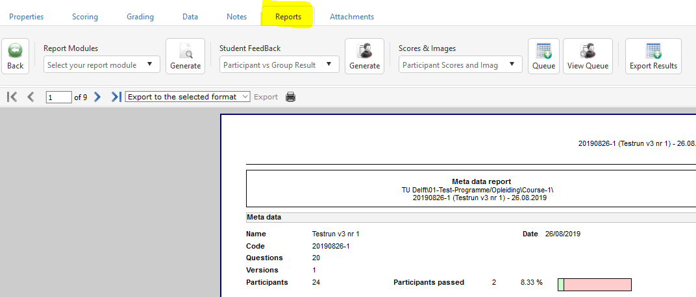

- Use the arrows to click through the report pages
- If you want to export the report, select the file format first.
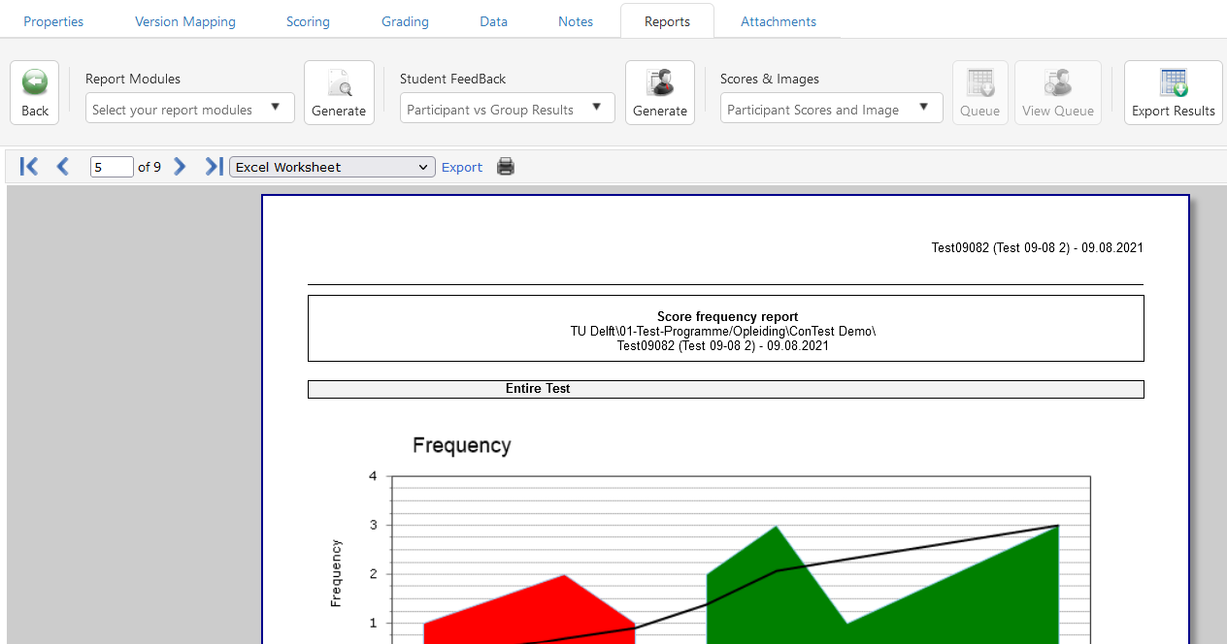

- After selecting the file format, click on Export
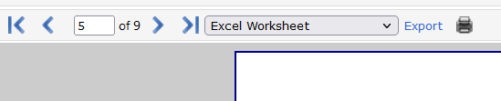

Extra: Three anti-cheating options (versioning)
There are three options that you can use to make cheating more difficult:
- Version mapping of question order
- Shuffled answer sheet
- Creating different exams
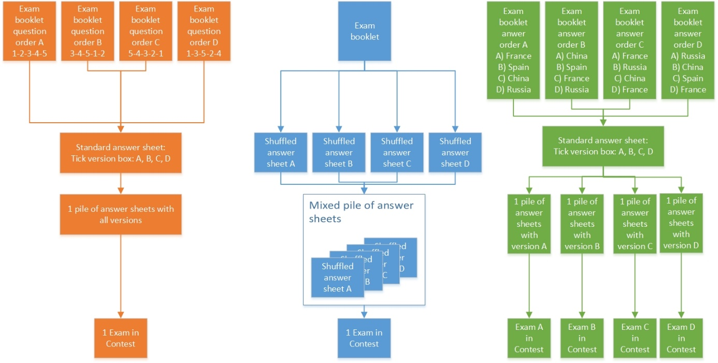

Overview of anti-cheating options. Orange: 1. Version mapping of question order; Blue: 2. Shuffled answer sheets; Green: 3. Different exams.

1 - Version Mapping of question order
To make cheating during a test more difficult, ConTest can create multiple versions of a set of exam questions by changing the question order.
It is NOT possible to change the order of the answers within a single exam!

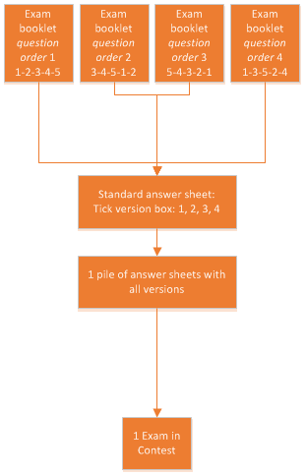

Comments:
- It is not possible to ask different questions in different versions.
- Changing the order might influence the difficulty of an exam. For example, it is more pleasant for a student to answer questions that have a logical order, and to start with an easy question. Therefore, it is not recommended to randomise the order in a version, since this might result in different performances for the different versions. It is advisable to keep a logical order and shift all questions by a fixed amount. ConTest enables you to change the order.

Using Version Mapping ConTest
Contest will help you shifting the order of the questions, using the concept of Version Mapping. When adding more than 1 version to the properties a new Version Mapping Tab shows.
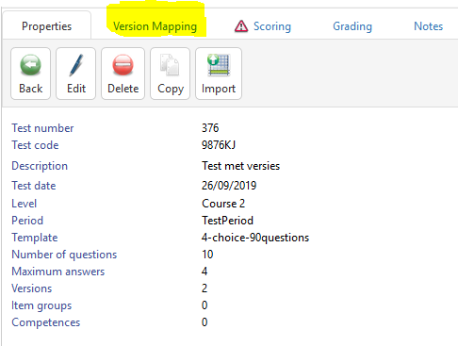

When using versions you create a master Test called Version 1. Next you create 1 or more additional versions of the same test (version 2, 3 and 4). In each of the additional versions, the only thing that you can change between the versions is the order of the questions.

You cannot change the order of the answer options. You have to ask exactly the same questions with the same answer options in the same answer option order. Only, the questions will appear in a different order.

When entering additional versions of a test ConTest supports four methods:
- Copy an existing version to another version. This is useful when there are 2 similar versions
- Shift a version by a certain number of questions.
- Reverse a complete version (see screenshot below)
- Manually enter for each additional version the corresponding question number in version 1.
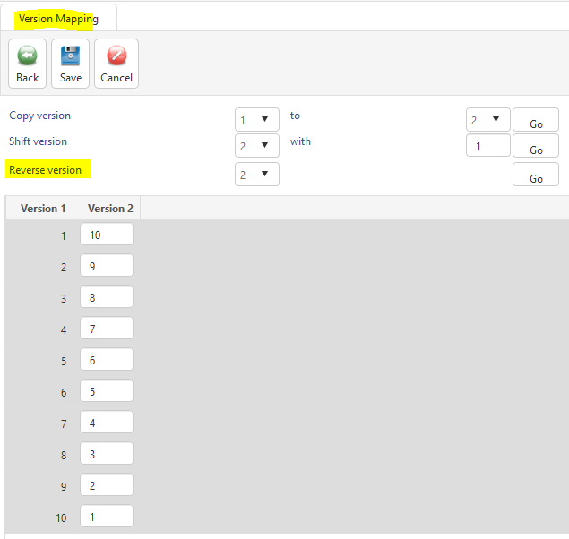

In the example above, the first question in version 2 is the last question in version 1.
In the exam of the student who has version 2, this question is number one. See below for an example:
Version 1:
1. What is the 101st ASCI character?
A. e
B. f
C. g
D. H
[questions 2-59]
60. What is the 160th ASCI character?
A. á
B. f
C. g
D. H

Version 2:
1. What is the 160th ASCI character?
A. á
B. f
C. g
D. H
[questions 2-59]
60. What is the 101st ASCI character?
A. e
B. f
C. g
D. H

2 - Shuffled answer sheets
The second option to make cheating during a test more difficult is to use answer sheets where the order of answers have been shuffled.

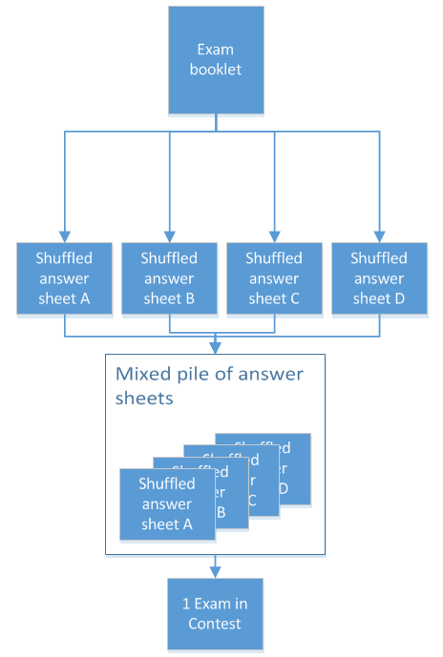

Example of shuffled answer sheet:
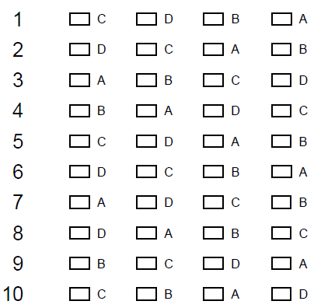

The names of the 4 answers sheets can be found at the top:

If you are using these answer sheets make sure you always use shuffle-A as your keyform.

Comments:
- The test is meant to measure how well student master the learning objectives. The shuffled type of answer sheets may lead to mistakes due to other factors. These random errors diminish the reliability of the grade, and lower the grades. This can most likely cause extra stress for students. To avoid this, make sure to have them practice writing tests with shuffled answer forms to help them prepare.
- You may need to take extra measures for students with special needs, like having them write the answers on a paper (e.g. ‘1.C’) and having the invigilators check whether these match the answer sheet.

3 - Different exams
The third option to make cheating during a test more difficult is to use 2 or more different exams. In order to keep the exams equally different, you are suggested keep the questions the same, but change the order of the answer options.

Contest cannot combine the results into one exam therefor you will have 2 or more test results.

You will have to hand in separate piles of answer sheets for each version of the exam at the ESA desk and you will receive separate files (results and test analyses) for each version.

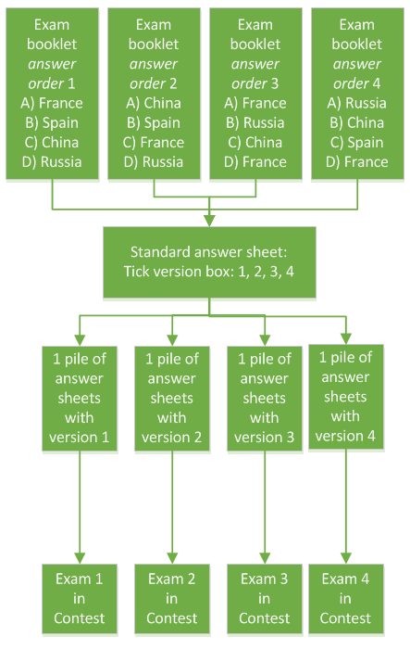

Questions and Contact

Help with | Function | Contact | Email
General information on Contest can be found here:
https://brightspace-support.tudelft.nl/contest/

If you have questions or need more support on educational aspects or interpretation of the test result analysis | Assessment advisor | 1. Your faculty’s ESA contact person  2. Assessment advisor at Teaching and Learning Services: Lisette Harting l.p.harting@tudelft.nl
Questions about functionalities or bugs/errors in ConTest. Or if you need support on technical or account related issues | Functional application manager | Eline Heinen/Gina van der Kooij | Fab-contest@tudelft.nl
Status of processing your tests after handing it over | DigitalExams |  | contest-os@tudelft.nl

