TUD_logo_blzw

**Manual**

**results registration**

**lecturers**





31 oktober 2018

**Contents**

[1 Introduction 3](#_Toc528738148)

[2 Instructions OSIRIS lecturer; How to register and sign test-results 3](#_Toc528738149)

[2.1 E-service registration mobile number required for electronically signing 3](#_Toc528738150)

[2.2 Entering marks 3](#_Toc528738151)

[2.3 Sign Electronically 5](#_Toc528738152)

[2.4 Sign Manually 6](#_Toc528738153)

[2.5 Sign results later. 7](#_Toc528738154)

[3 Other options 8](#_Toc528738155)

[3.1 Correct grade 8](#_Toc528738156)

[3.2 Read results with an Excel file. 9](#_Toc528738157)

[3.3 Read results with a text-file 10](#_Toc528738158)

[3.4 Adding a student 10](#_Toc528738159)

[3.5 Clearing grades 10](#_Toc528738160)

[3.6 Details test grade 11](#_Toc528738161)

[3.7 How do I search an old test? / how do I search for a test without open enrollments? / how to register a result on a bachelor project. 11](#_Toc528738162)

# Introduction

The lay-out of the Self Service module of OSIRIS lecturer is recently updated. The module was incompatible with present-day requirements. That’s why the module was given a new look and feel.

All concepts and notions like ‘Courses’ or ‘Test’ remained the same. Also, all procedures regarding exemptions, signing electronically, etc. have not changed.

This manual describes how to register test results, and how to sign them electronically. In the chapter ‘ Other options’ will the other options in OSIRIS Lecturer be discussed.

This manual is meant for lecturers and describes the registration of test results due to this update. The used data is fictitious.

# Instructions OSIRIS lecturer; How to register and sign test-results

In the next few paragraphs we will describe step-by-step how to register marks on a test, and how to sign them electronically.

## E-service registration mobile number required for electronically signing

In order to receive the SMS-code, necessary for identification for electronically signing, the application requires registration of a mobile number in E-service. This application can be found at

<https://e-service.tudelft.nl/>. Login with your NetId.

Set the mobile number used for this purpose, according to the following format:

[Countrycode (+31)][space][Mobilecode (6)][space][Number]



For security reasons the mobile number has extra requirements:

* It has to be unique.
* Previous used numbers cannot be reused.

## Entering marks

Go to <https://osidoc.tudelft.nl>. Login with you NetId

After logging in successfully, you will automatically see the new dashboard. This is the central place of OSIRIS Lecturer. You can find all the tasks which you have to do, for instance, how many test results you will have to register.

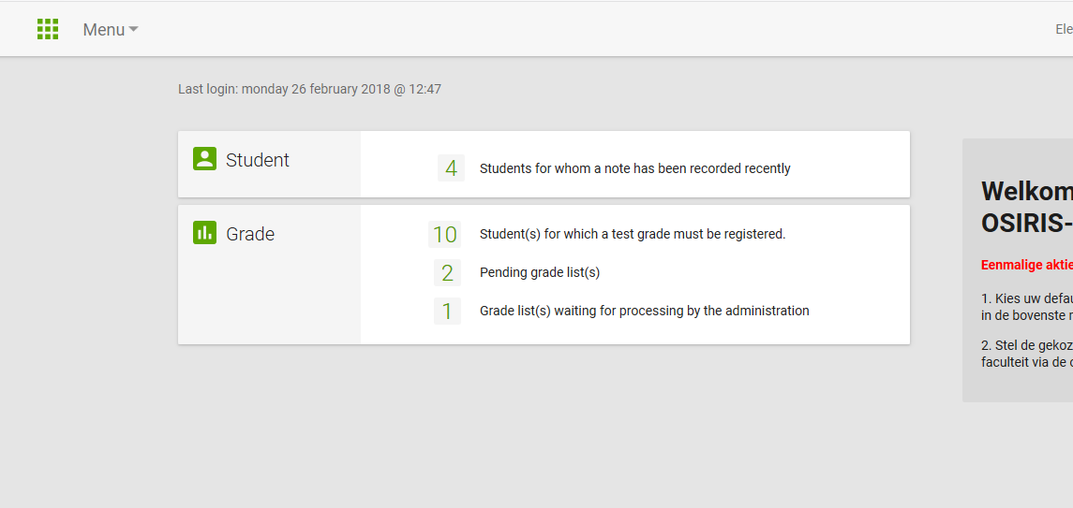

In the dashboard, you immediately can see how many ‘ regular’ test grades you have to register and how many grade lists, you have to sign.

* To register marks, you can click on the number, here 10.

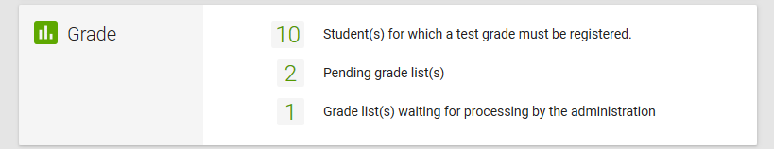

A screen will open with the different test for which you can register results. Per test you can see the current status (How many enrollments have *No Grades*, hoe many grades are *pending,* and how many grades are completed).

The screen Grades - Tests displays a lecturers individual workload. When a course/test has more than one lecturer, OSIRIS will display the workload for the individual lecturer as 0.

To display all students that have registered on the test please tick the box **Status: Total for all lecturers** upper right in the screen.



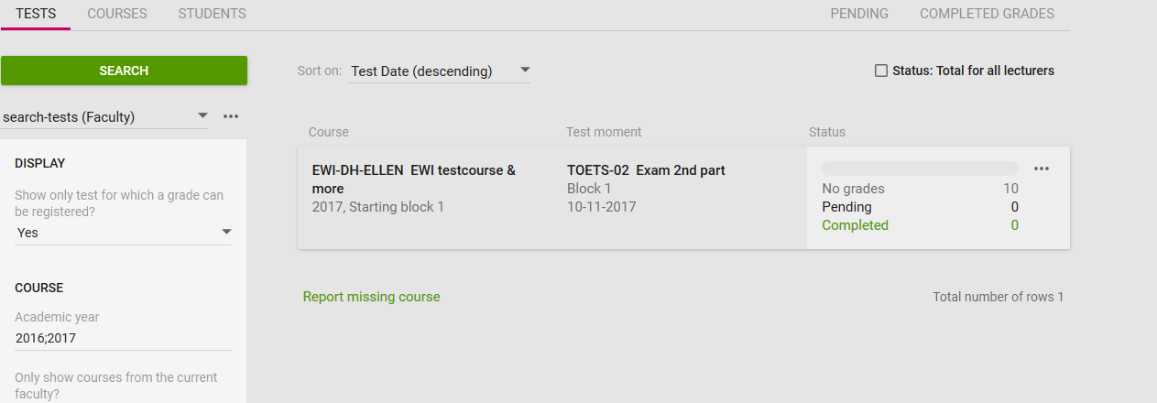

* To enter results, click on the desired Test.

A screen will open where the results for this test can be registered.

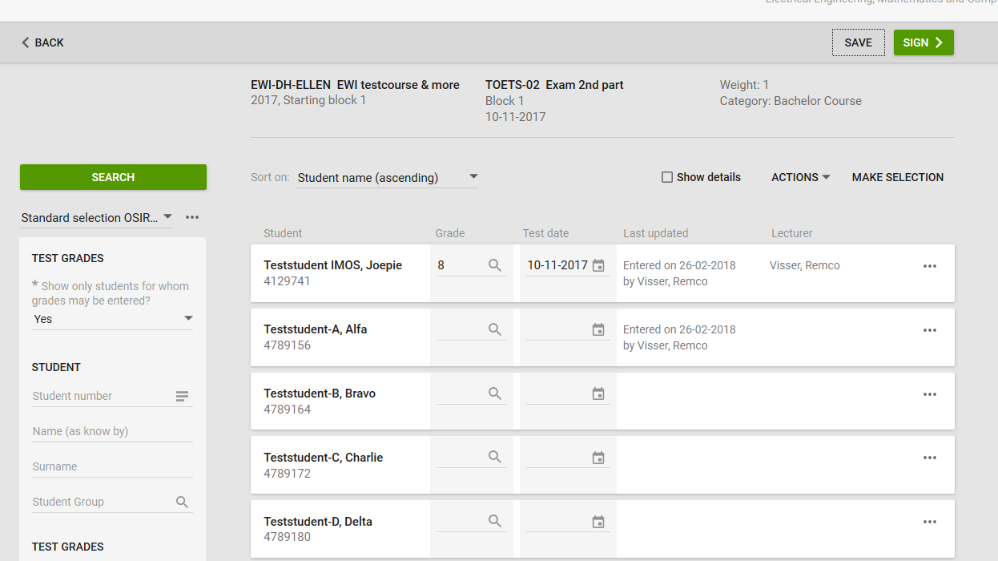

- Register the **Grade** and the **Test date** at the desired student.

- When registering the next grade, the date will be filled out automatically.

- Click on <**Save**> to save your progress. The results are now status <**Draft**>. This means that you can still change the grade, and students cannot see them yet.

* Click on <**Sign>** to sign your grades directly. You will see two possibilities to sign:



1. Sign Electronically = Our option of choice: for signing directly with an SMS Code.
2. Sign Manually = our back-up option: a PDF is generated, which has to be signed and handed in at the O&S Administration.

It is also possible to sign the results later on. This will be discussed in a paragraph 2.5.

## Sign Electronically

The process of signing electronically has not been changed. After clicking on <**sign electronically**> a screen will open.

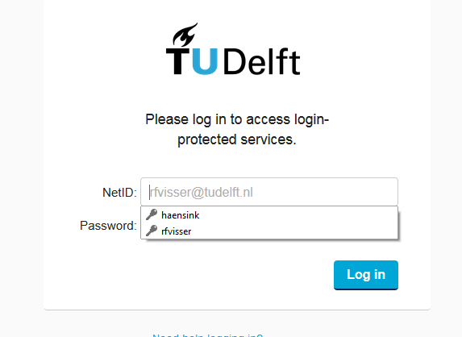

After logging in with your Net-ID, an **SMS** will be send to your mobile number. Also, a new screen will open:

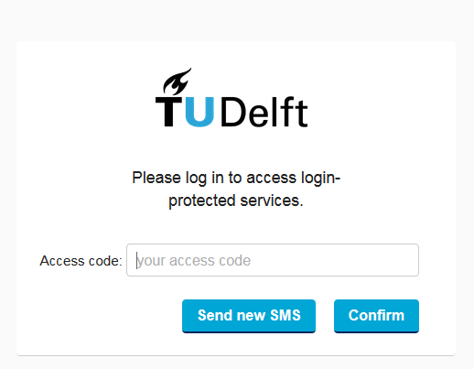

Please enter the **received SMS-code** and click on <**confirm**>. The grades are now signed, the status is <**final**> and the results can be seen by students.

## Sign Manually

Signing manually is the not-preferred back-up option. After clicking on the button <**sign manually**> a pop-up wil appear with a generated PDF:

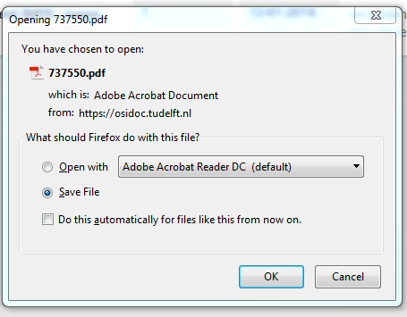

This PDF has to be printed, signed and handed in at the O&S administration.

## Sign results later.

Saved results (**draft results**) can always be signed later. On the dashboard you can find the number of grade lists that still have to be signed, here 3.

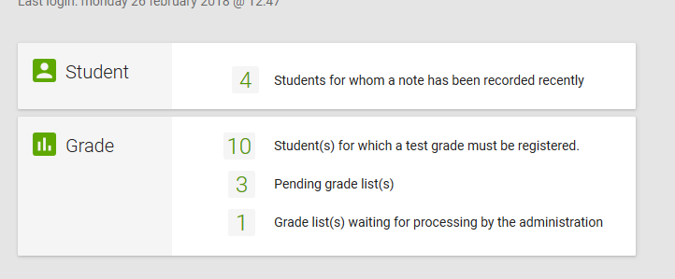

By clicking on the ‘ 3’ a new screen will open with the different grade lists.

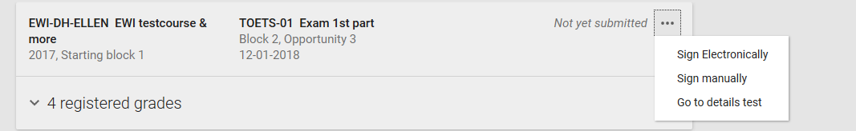

By clicking on the three dots [ **. . .** ], next to the grade list, you can make a choice how to sign the grade list.

Also, multiple grade lists can be signed at the same time. Click on <**Make Selection**>, and check the boxes of the grade lists you want to sign.

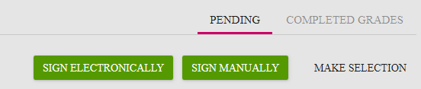

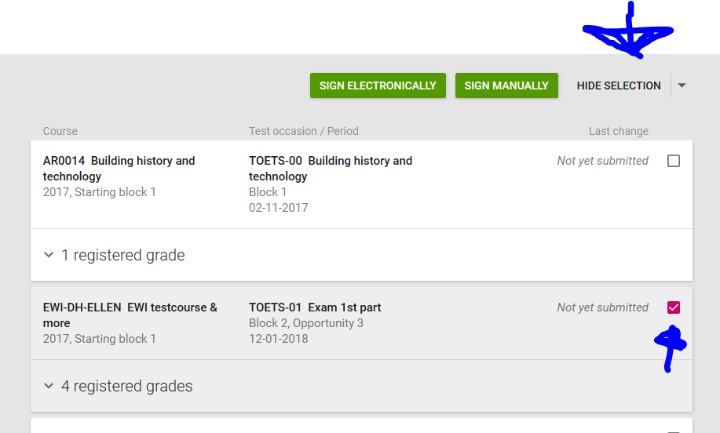

Again, you have the option of signing the results, electronically of manually.

# Other options

## Correct grade

It is still possible to correct final grades. This, within the same 35 day period. To correct a final grade, you can use the action <**correct grade**> in the screen ‘ registering test results’.

* Search for the test using the different filters.
  + Only test with open results will be shown. Change the filters if necessary.
* Click on the test in which you want to correct a grade.
* Change the filter ‘ Show only students for whom grades may be entered?’ to ‘ **No** ’ .

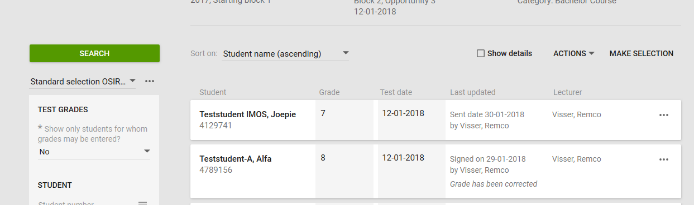

* Click on the three dots [ **. . .** ], next to the result

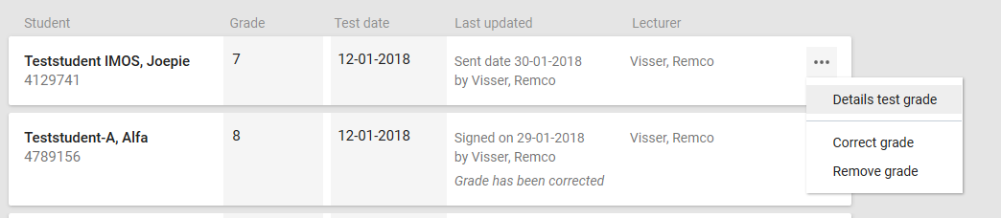

* Click on the action: <**Correct Grade**>.

The status of the result will change from <**final**> to <**draft**> and you will be able to change it.

**The result has to be signed again to become <final> again.**

Corrections of grades is not possible after 35 days. After 35 days a result can only be changed at the O&S administration.

## Read results with an Excel file.

In OSIRIS lecturer an Excel file with results can be uploaded to the test.

* After selecting your test, click on <**actions**> and ‘**Create file’**

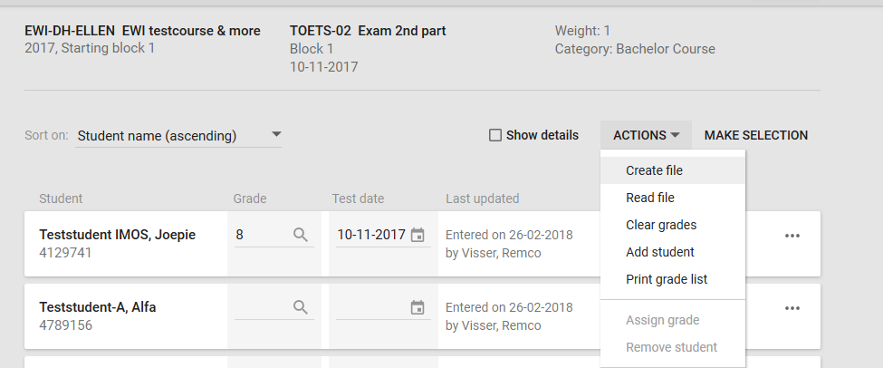

An excel file is created.

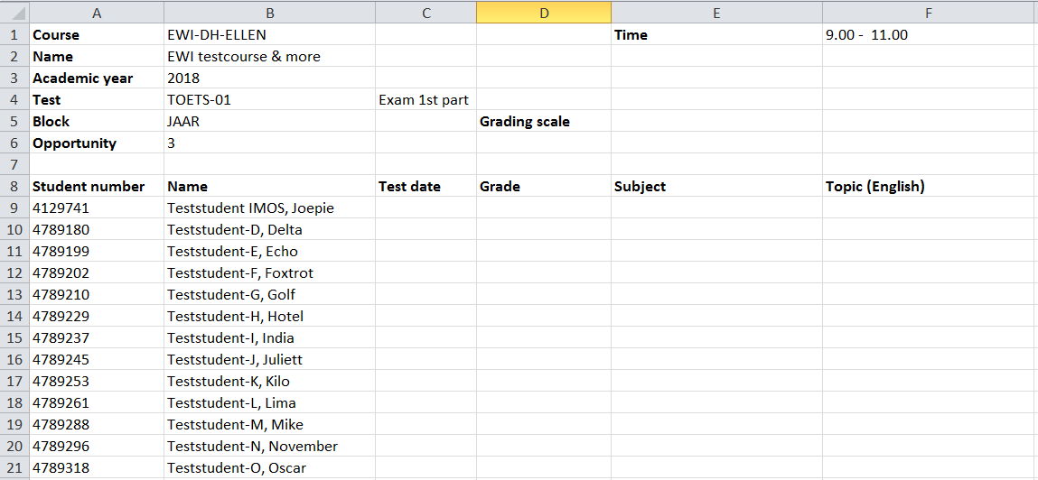

* Register the <**test date**> and the <**grade**>.
* <**subject**> and <**topic**> are optional
* Save the file on you harddrive.
* Select <**actions**> again, and click on <**read file**>
* Select the saved file and click on <**read file**>

## Read results with a text-file

With the same action, <**read file**>, a text file can be read into OSIRIS.

The text-file has to contain two columns, divided by a <**tab**>:

Studentnumber <tab> grade.

For instance:

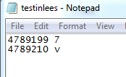

## Adding a student

Sometimes it will be necessary to add a student tot the test.

With the action <**add student**> you can add a student to the test.

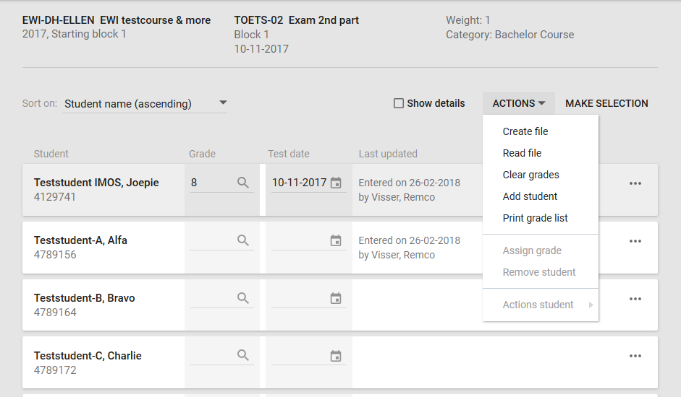

## Clearing grades

When results are still status <**draft**> and not yet signed, they can be cleared.

You can do this manually, one by one, or with the action <**clear grades**>.

With this action you can clear all results that are not yet signed.



## Details test grade

With the three dots [ **. . .** ] next to the testgrade you can see the details of the test grade.

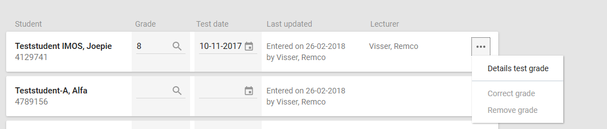

The pop-up shows the (history of the) final grade, the history of the test result and de results of the other tests belonging to the course.

## How do I search an old test? / how do I search for a test without open enrollments? / how to register a result on a bachelor project.

By default, OSIRIS Lecture shows only tests for which a grade can be registered. It is possible that you have to register a grade for a test for an old course, or a test without open enrollments.

A good example is **the Bachelor thesis**.

You can do this by clicking on <**grade**> in the dashboard. In this screen, where you can select your test, change the filter ‘ Show only test for which a grade can be registered’ to ‘**No**’.

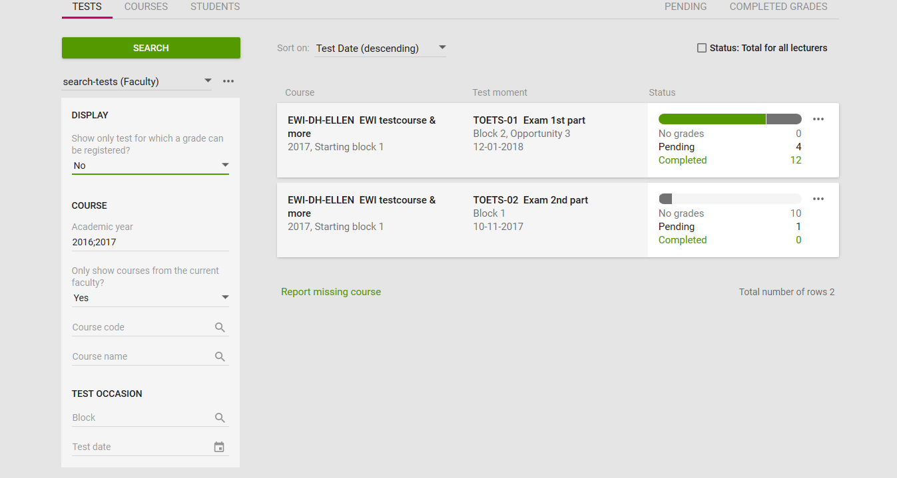

Osiris lecturer now shows all the tests which you are linked to. Search for the right test, <click> on the test, and add a student to the test.

When you have added a student to the test, you can give him/her a result etc.