Quick Reference Guide: Results Processing for Lecturers

Mobile phone number for electronically signing results in OSIRIS beforehand (one-off registration)

In order to be able to sign results electronically in OSIRIS the lecturer must register a mobile phone number for this purpose in the E-service application. This can be found at https://e-service.tudelft.nl/. You must log in using your NetID.

Enter the mobile phone number used for this function in the 'Mobile phone' field using the required input format: [country code (+31)] [space] [mobile code (6)] [space] [number]. See the example.
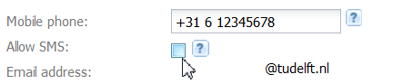
The field 'Allow SMS' is not necessary for this application. You can leave this empty.

Note: For security reasons, the mobile phone number is subject to a number of requirements.
- It must be unique within TU Delft. You cannot submit a mobile number that is already being used in the E-service application.
- Re-activation/re-entry of previously entered numbers is also blocked.

Step 1. Entering results in OSIRIS Lecturer

The OSIRIS Self Service Lecturer module is available on: https://osidoc.tudelft.nl
Please login with your NetID.

On the dashboard, it is clear how many results have to be registered. In this example 22 test grades have to be registered.

Click on the number (here 21). A screen will open with all the tests for which test results can be registered. Then choose the test of your choice. 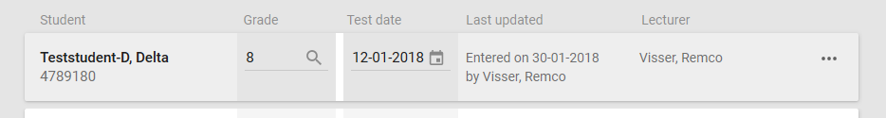

Register the <results> and <test dates> for the desired student(s) and click on <Save> at the top of your screen. The result is now status <draft>. These results are no shown to students and you can still mutate them.
The fields 'Last updated' and 'Lecturer' are automatically filled by OSIRIS.

Note: If a student does not appear in the list, he/she can be added.
- Click on the <ACTIONS> button and select <Add Student>
- Find your student and click on the <Add Student> button again.
- The added student will then appear in the list.

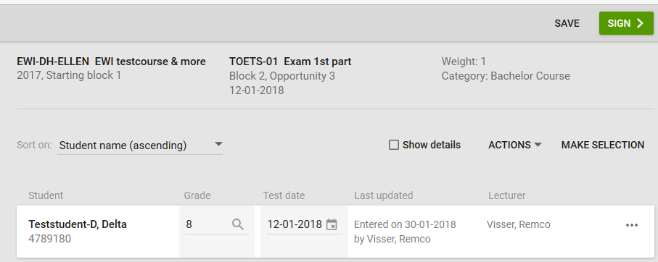
Step 2. signing results in OSIRIS Lecturer

You can now sign the results. This can be done immediately after entering results. Or later, via the dashboard. In case of direct signing after entry you have to click on <sign>.

Via the dashboard you can click on the grade lists that are ‘pending’. These are the tests for which you have registered results but haven’t signed yet

Subsequently, for both methods, you can opt for <sign electronically>.

A new authentication screen will be opened.
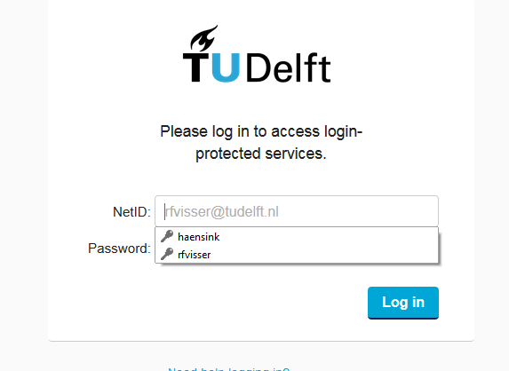

Use your NetID password to log in on the authentication screen.

Upon loggin in, an SMS code is sent to your mobile phone.

A new screen will be opened to enter the SMS code.
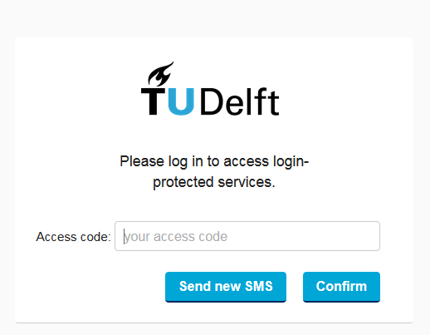

Enter the SMS code sent to your mobile phone and click on Confirm. The code is not case-sensitive.

The results are now status <final>. You cannot mutate them anymore, and the student can see their results.

